L3 report 2012-05-11

Thomas Sievert, Lars Woxberg, Fredrik Johannesson, Martin Säll, Kim Restad

KIMportant REST ADditions

# State machine

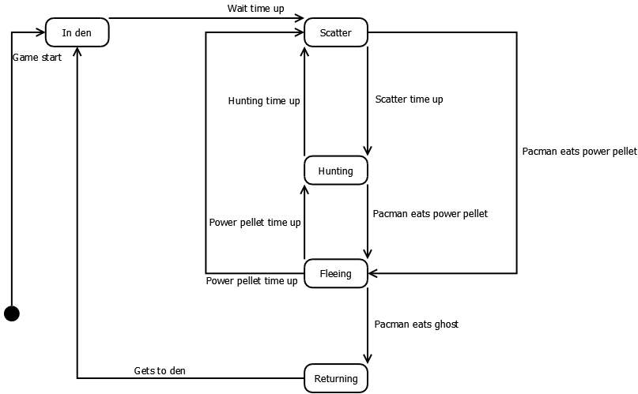

The different states in Pacman::Reloaded are quite simple. Ghosts start in the den, and then go out to hunt Pacman. They alternate between scattering or hunting the hero. If Pacman eats a power pellet, they will be scared for their lives and try to run away. Should Pacman happen upon one of them and eat him, he will turn invisible and sullenly return to the den before he can resume is hunt.

# Prototype

The video prototype can be found by pasting the following URL hyperlink into one's preferred Youtube video playback application.

http://www.youtube.com/watch?v=jodGjLDOFgM&feature=colike